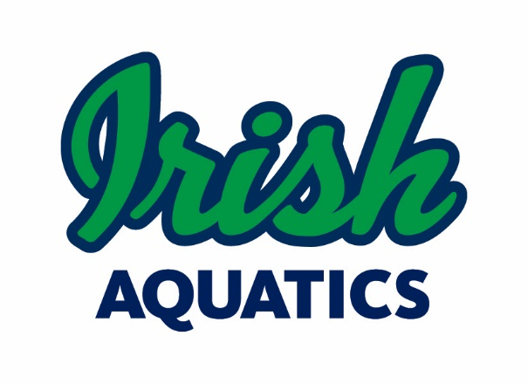
Legal Guardian Authorization for MAAPP 2.0 Exception
Massage Therapist or Athletic Trainer

I, Parent/Guardian's Name, legal guardian of Minor Athlete's Name, a minor athlete, give express written permission, and grant an exception to the Minor Athlete Abuse Prevention Policy (MAAPP 2.0) for Therapist/Trainer's Name to provide massage, rubdown, and/or an athletic training modality to Minor Athlete's Name on Date at Location. The massage, rubdown, or athletic training modality must be done with at least one other adult present in the room and must never be done with only the minor athlete and the therapist/trainer in the room. I acknowledge that I have the right to observe the massage, rubdown, or athletic training modality. I further acknowledge that this written permission is valid only for the dates and location specified herein.

Legal Guardian Signature:
Date:

This waiver must be filled out each for each planned session or series of recurring sessions and will remain on file with Irish Aquatics. Please send the completed form to Coach Matt (coachmatt@irishswimming.org) and the Safe Sport Chair (safesport@irishswimming.org).

